DESIGNING THE WORLD AROUND ME: MATHEMATICS AND CULTURAL INSPIRATION IN DESIGN
Description
The activity supports the development of geometric understanding through the use of two dimensional shapes in cultural and religious symbolism and though their use in architecture, particularly in the use of tiling. Throughout there are opportunities for exploring how symbolic representations are underpinned by ideas and beliefs. There are eight tasks.
Global citizenship competences addressed
- appreciate different perspectives & world views
- positive interactions with people who are different
- take constructive action for social well-being
- analytical & critical thinking skills
- communication & co-operation skills
Global citizenship content
Inclusive social relationships; intercultural exchanges; knowledge of other cultures; historical awareness
Mathematical approaches
- looking for patterns and connections
- asking yourself questions
- visualising, imagining and using intuition
- using argumentation and reasoning
- recognising the social and ethical dimensions of mathematics
- questioning the use of mathematics in structuring experience of the world
Mathematical content
Names and properties of two dimensional shapes; reflective and rotational symmetry, factors, primes ad co-primes; regular and semi-regular tiling
Resources required
Rulers; mini whiteboards for pairs; one large laminated 10 point circle for each group; 15, 20, 25, 30 and 48 point circles; colours and a variety of design resources; access to computers; a plentiful supply of triangles, squares and hexagons with equal side length; cameras
Time needed (in and out of the classroom)
Approximately nine hours curriculum time.
Organization and practical issues
Whole class teaching plus small groups. Task 7 is best begun as a homework activity.
Suggested plan for teaching
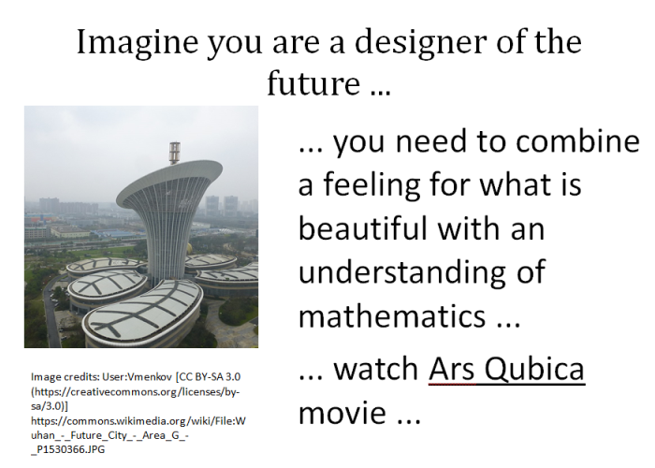
Task 1: Thinking about mathematics and design (approx. 1 hour)
Imagine you are designers of the future.
Show PowerPoint slide 2. Explain that this activity is about using mathematics and our cultural heritage to create pleasing designs.
What does a designer need to know in order to make people feel good?
The children discuss in small groups for a few minutes and then a simple list of all their suggestions is created on the board. Possibilities are mathematics, aesthetics, imagination, creativity, knowledge, skills, a committed attitude, practice.
Now show the Ars Qubica video as as a stimulus for a philosophy discussion. Working in their groups, the children share questions they have arising from the video. They decide on one that they would like the class to discuss. The children sit in a circle and each group's question is shared with the class. The class vote on the question they would like to start by discussing - you may like to do this by the children standing facing out and indicating their choice by thumbs up behind their back. A class dialogue then follows. The dialogue will be more like building something together than exchanging ready-made opinions - the P4C teachers' guide (https://p4c.com/about-p4c/teachers-guide/) has many ideas about how to facilitate this. Focusing throughout on collaborative, caring, creative and critical thinking and vocabulary will support the development of critical citizenship and global learning skills and dispositions.
The basic approach of Ars Qubica is to convey the presence of geometry and mathematics in art. Here, the figure of a cube is used as the guiding thread, a geometric figure that, when cut by a plane, can give rise to a square, an equilateral triangle, a non-regular pentagon or a hexagon. Links are made to different artistic and ornamental works.
Task 2: Designing with regular polygons (approx. 1½ hours)
Give each pair of children a mini white board. Ask the class for the names of shapes they know. Collect as many as possible, sketching the shapes too if appropriate, and keep waiting until they have suggested some polygons and some non-polygons (for example, circle, cube, semi-circle, cylinder, curve).
A set of interesting mathematical shapes are called polygons.
Put a tick by each of the polygons.
Talk to your neighbour and name or draw another shape that would get a tick and one that wouldn't.
A polygon is a
- closed
- 2-D shape
- with straight edges.
Share some of the results then give the formal definition of a polygon. It has three essential properties. Split the class into three - some to break the first rule, some the second and some the third. Ask each pair to draw a suitable shape on their mini whiteboard. Share and discuss the results.
So each part of the definition is needed.
A regular polygon has all sides and all angles equal.
A regular polygon has all sides and all angles equal.
Ask the students to sketch shapes that show, again, that both parts of the definition are needed.
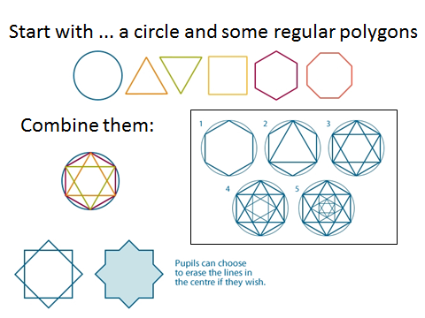Images credits: School of Islamic Geometric Design (http://www.sigd.org/resources/)
Using slide 3 as a stimulus, give children 48 point circles and ask them to make a design using the shapes from the slide and/or any other regular polygons that can be made by joining the dots. The children colour their designs in ways they choose.
The final results will be used to form a display.
Task 3: Finding and making symmetries (approx. 1½ hour)
Use blu-tac to display the children's designs on the board.
How might we group the designs? Which ones could go together? What possibilities do you see?
By offering the rest of the class the opportunity to ask questions, encourage the children to express their ideas clearly and accurately. Regroup the designs to reflect each grouping suggested. Expect lots of intriguing ideas and help the chidden to draw out the mathematics involved in their classifications.
One way we could classify them is through rotational symmetry.
Group some of the designs using this classification. Ask the children to discuss where the remaining ones should be placed.
Almost all of their designs will have both reflective and rotational symmetry. If necessary, have one of your own prepared that has only rotational symmetry. introduce the concept of rotational symmetry. Use your example and any of the children's that also have rotational symmetry but not reflective symmetry. Use the vocabulary of orders of symmetry. (All symbols have rotational symmetry order 1 but we do not say these shapes have rotational symmetry.) Draw out that any shape with reflective symmetry order 2 also has rotational symmetry order 2.

Make a copy of your design. Colour it so that it has rotational symmetry only.
Make a display and share the results through eTwinning.
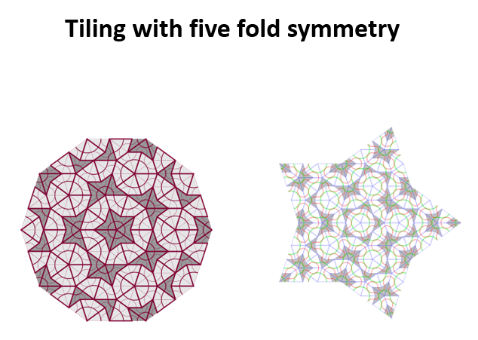
Image 1: https://commons.wikimedia.org/wiki/File:Penrose_sun_3.svg
Image2: https://commons.wikimedia.org/wiki/File:SSS_Penrose_tiling,_4iter,_star.svg
What orders of symmetry did our designs have? What do you notice about all these numbers?
They are factors of 48. What orders could we not make on a 48 point circle?
Task 4: Pentagonal symmetries (1 hour)
Use PowerPoint slide 4 to discuss the orders of symmetry that are found in Islamic designs. Slide 5 shows some images of Islamic tiling with five fold symmetry.
Discuss the pentagon and the five pointed star - the pentagram (slide 6). The pentagram has been important in many different cultures. It is said to be the secret sign of the Pythagoreans.
Follow this with a visualisation exercise.
Everybody sit comfortably with your hands in your lap or folded on the table. Close your eyes. Breathe deeply and quietly and relax.
Imagine a circle with ten dots spaced evenly round the circumference.
Make the circle bigger and go inside it. Come out and look at it from the outside.
Shrink the circle until it is tiny. Can you still see the dots?
Bring the circle back to a comfortable size.
Starting from the top go round the circle joining each dot to its neighbour. Look at and remember the shape you have made.
Wipe away the lines but keep the circle and its dots. Now go round the circle joining every other dot by missing one dot out each time. Look at and remember the shape you have made.
Open your eyes and discuss with a neighbour what you have seen.

The children can share and discuss their images with the class.
Now repeat the exercise. Explain that this is much harder. This time they miss out two dots each time. Give time for this exercise. Again the children discuss with a neighbour.
Give each small group a large laminated 10 point circle for them to check out their ideas.
What other shapes can you make? What rule do you use each time?
Collect together and share ideas.
Now we are going to focus on the pentagram. We visited every fourth point (by missing out three).
Hand out 15, 20, 25 and 30 point circles to different groups.
How many spaces to create a pentagram on your circle?
Any who finish quickly can think about a 35 point circle. Collect all the results.
What do you notice about these numbers?
Use the words ratio and fraction in supporting the students' discussion.
Using the electronic worksheet http://tube.geogebra.org/material/show/id/1385121 the students test out their predictions for 5, 35 and 40.
Task 5: Designing a symbol to represent our class (1 ½ hours)
Slides 7 to 12 include a variety of symbols from a variety of different cultures and historical times. All of the symbols have mathematical properties. Discuss the symbols with the class and encourage the students to discuss the symmetries of the symbols and the meanings conveyed by this and by other properties of the designs.
Use slide 13 and the 3 minute movie about Isfahan (https://www.youtube.com/watch?v=QqbiDdsaZw4) as a stimulus to think about tiling patterns.
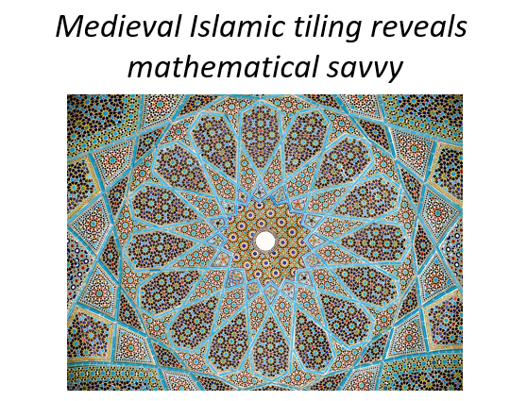
Share this simplified version of an article and the three images from the New Scientist (https://www.newscientist.com/article/dn11235-medieval-islamic-tiling-reveals-mathematical-savvy/):
Medieval Islamic designers used elaborate geometrical tiling patterns at least 500 years before Western mathematicians developed the concept.
The geometric design, called girih, was widely used to decorate Islamic buildings but the advanced mathematical concept within the patterns was not recognised, until now. The 15th-century tiles formed so-called Penrose geometric patterns. Penrose tiling is a concept developed in the West only in the 1970s.
Girih designs were assembled from five regularly shaped tiles, including a bowtie shape, a rhombus, a pentagon, an elongated hexagon, and a decagon (slide 14).
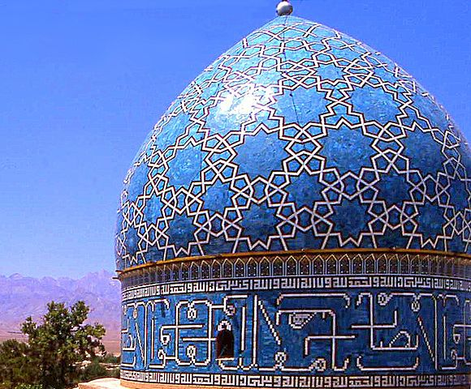
Image source: https://commons.wikimedia.org/wiki/File:Shah_Nematollah_Vali_Shrine_13_detail.jpg Author: anaareh saaveh
The atoms in certain materials can arrange themselves in similar non-repetitive patterns, which are called quasi-crystals. They are called this because they have a well-defined structure but the atoms are not spaced uniformly as in a normal crystal.
The correspondence between mathematically determined design and the natural world is always intriguing. The students may like to consider if there are other types of correspondences – between mathematics and soul, for instance.
Using everything they have learnt so far, including the meanings of symbolic representations, the students work in small groups to design a symbol to represent their class. Begin with a discussion about what is important about the values that the class share, what types of relationship they might depict and so on.
What motifs might you use? How will you represent our relationships and our learning community? How will you use symmetry?
Share the finished designs and discuss them as a class. What types of relationships have they depicted? What shapes did they use and why? Did any of them use symmetry to represent relationships? Did any of the groups try to represent fairness and balance?
The class can share their symbols through eTwinning.
Task 6: Exploring tiling with regular polygons (1 ½ hours)
Explain that the students are going to begin by thinking about very simple, regularly repeating tiling patterns.
The simplest tilings use just one shape. If we use just regular polygons we make a regular tiling. How many are there? How do we know we have found them all?
There are a number of different ways to complete this argument. For example, a triangle has the least number of sides and it tiles (six meeting at a vertex). Next is the square and it tiles (four meeting at a vertex). We know the hexagon tiles (three meeting at a vertex) …
To explore tiling with regular polygons further, you will need a good supply of triangles, squares and hexagons sharing the same side length. A good supplier of these can be found at https://www.atm.org.uk/Shop/MATs---View-All
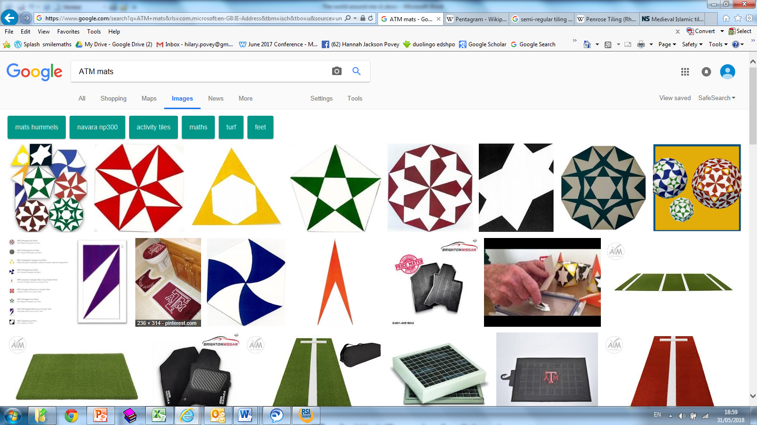
First the students freely explore tiling patterns using some or all of these three shapes. Introduce the rule that the tiling patterns must be periodic, that is, the pattern repeats regularly across the plane in all directions. They take photographs of designs they find pleasing. These can be shared through eTwinning.
How could we group or classify our designs?
A semi-regular tiling uses regular polygons of more than one type. In addition, every vertex where the tiles meet has to be the same.
If we introduce a new rule, that the tilings have to be semi-regular, we will find that only a few of these patterns are allowed.
Are any of our patterns made so far semi-regular?
There are five semi-regular tilings that can be made with just these shapes. Can you find them all?
Can you prove there aren’t any more? (Hint: Consider the possible ways the shapes can meet at a vertex.)
Task 7: Tiling patterns in the world around me (1 hour)
Show the students an image of one of the semi-regular tilings from the last activity found in the tile floor from the Museo Arqueológico de Sevilla, Spain (slide 15) (https://commons.wikimedia.org/wiki/File:Semi-regular-floor-3464.JPG)
Tiling patterns are used all around us in both ancient and modern buildings.
The students look for tiling patterns in the environment. They take photographs to share and discuss the mathematical properties of the tilings they have found. This provides another ideal opportunity for eTwinning where they can share their images and their mathematical analyses.
Task 8: Reflection on the nature / rules of the social world around me (1 hour)
In Task 5 you designed a mathematical symbol to represent the class.
We want our class to be a learning community where everyone has equal worth and everyone is valued. Does this mean we all have to be the same?
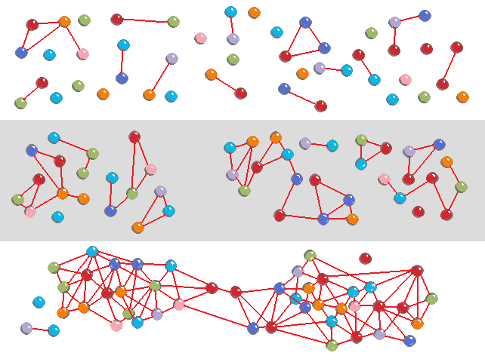
Look at these two images that could represent a social world.
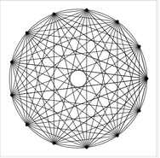
https://demonstrations.wolfram.com/TheMysticRose/ https://en.wikipedia.org/wiki/File:Network_self-organization_stages.png Takemori39
Michael Croucher CC BY-NC-SA
In small groups the children discuss the beauty and the limitations of the images as representations of the social world.
What pulls people together and what sets them apart?
What is needed to become the friend of somebody from another part of the world?
Do you think you could find something in common with every child on this planet?
Extending the learning
Possible discussion themes to be explored further starting from the students’ drawings attempting to represent their class are:
- equality
- diversity
- inclusion
- equity
Other resources (material and human resources)
Videos:
http://www.etereaestudios.com/docs_html/isfahan_htm/isfahan_movie_index.htm#
http://www.etereaestudios.com/docs_html/arsqubica_htm/index.htm
Web links:
School of Islamic Geometric Design. Resources. Online: http://www.sigd.org/resources/
School of Islamic Geometric Design. Basic Design Principles. Online: http://www.sigd.org/resources/basic-design-principles/
Lu, Peter J. & Steinhardt, Paul J. (2007). Decagonal and Quasi-Crystalline Tilings in Medieval Islamic Architecture. In: Science 23 Feb 2007:
Vol. 315, Issue 5815, pp. 1106-1110. DOI: 10.1126/science.1135491 Online: http://science.sciencemag.org/content/315/5815/1106
Dunham, Will (2007). Islamic maths was 500 years ahead. [Reuters] Online: http://www.abc.net.au/science/articles/2007/02/23/1855313.htm
Hecht, Jeff (2007). Medieval Islamic tiling reveals mathematical savvy. In: Daily News. Online: https://www.newscientist.com/article/dn11235-medieval-islamic-tiling-reveals-mathematical-savvy/
National Centre for Excellence in the Teaching of Mathematics (2009). The Art of Mathematics Islamic patterns. In: Primary Magazine - Issue 13: The Art of Mathematics. Online: https://www.ncetm.org.uk/resources/18030
NRICH Enriching Mathematics. Islamic Tiling. Tiling with Equilateral Triangles. Serendipity. Online: https://nrich.maths.org/1561 , https://nrich.maths.org/1545 , https://nrich.maths.org/1559
Images:
https://www.ancient-symbols.com/religious_symbols.html
http://mathworld.wolfram.com/HeartCurve.html
https://www.shutterstock.com/search/social+science
Ethical issues or dilemmas
Designing a symbol to represent the class may raise ethical dilemmas especially with respect to inclusion and diversity:
We have similar minds and hearts - why don’t we have the same beliefs and expectations? Do we all have the same rapport one to each other? Based on what criteria do you share ideas or resources with your classmates? Can the relationships among members of your class can be represented regularly, as equidistant from one to another?
Are differences among people beneficial or harmful for a group? Do we have the same type of shrine? How do other beliefs guide the life of people?
In Task 5, guided by teacher, students are exploring and discussing significations attributed to different religious symbols. The teacher should avoid attempts to categorise or assign inappropriate connotations to symbols or to ideological conceptions.

