FAIR & SQUARE: MAGIC, LATIN & VEDIC SQUARES
Description
Magic squares have been created and used by many different cultures since ancient times. They have a beauty and symmetry that can give satisfaction to those who enjoy solving puzzles. They can also give important messages about balance and interdependence and have led to applications in various areas of life. (See the section at the end of this unit on ‘Ethical Issues and Dilemmas’ for a discussion on the use of the term ‘Magic’ in relation to Magic Squares).
The activity is based on seven tasks.
Global citizenship competences addressed
- appreciate different perspectives & world views (acknowledging the contribution of Chinese, Indian and other cultures to mathematics)
- positive interactions with people who are different
- analytical & critical thinking skills
- communication & co-operation skills.
Global citizenship content
Buen ViVir (social ecological integration); Environmental Sustainability; Legacy of Colonialism; Interdependence; Alternative Knowledge Systems; Culture & Intercultural Relations.
Mathematical approaches
- developing a love of numbers
- looking for patterns and connections
- being organised and systematic
- being resilient and flexible
- conjecturing and checking things out
- visualising, imagining and using intuition
- using embodied and multi-sensory approaches
- using representation and symbolism
- using argumentation and reasoning.
Mathematical content
Number patterns and operations; rotational symmetry; understanding algorithms; tiling patterns. The topic is very rich and other areas may be covered.
Resources required
PPT slides; numbered coloured sheets for Task 1; masking tape; multi-link cubes, lego or similar, a potato; a compass; coloured crayons and rulers; downloaded music; squared paper; a copy of the whole school timetable; copies of the worksheets Dotty squares 1, Dotty square 2, Sudoku1, Sudoku 2 (possibly laminated), The Vedic square.
Time needed (in and out of the classroom)
Approximately eight hours curriculum time.
Organization and practical issues
Pupils will be working in groups of ten for the first activity and, because of its kinaesthetic nature, an area of floor space will be needed, perhaps at the front of the class for the initial activities and a larger space for the final part of Task 1.
Suggested plan for teaching
Task 1: Introducing the Luo Shu 3 x 3 magic square (approx. 2 hours)
This introduces and encourages pupils to create and explore a Latin square kinaesthetically and then the ancient Chinese Luo Shu 3 x 3 magic square. The PowerPoint presentation Fair and Square Slide 2 tells the story of Emperor Yu and the turtle using the slide as an illustration. The Luo Shu square is a unique 3×3 magic square with non-repetitive numbers. A magic square is a grid of numbers for which every row, column and diagonal adds up to the same number.
To recreate this square the class will need to be divided into three groups of nine or ten (any remaining pupils can observe the process and report back):
- In the first group, nine pupils are first asked to come to the front of the class (or another suitable space) and arrange themselves into a square, three rows by three columns. The tenth pupil (or a pupil from another group) then adds up the pupils in each row, column and diagonal and calls out the totals (which should be 3 in each case). This is to establish the shape and nature of a number square and the vocabulary involved.
6 6 6
5 5 5
4 4 4
The initial formation
Next, each pupil is given a coloured, numbered sheet of paper as shown. They now need to form into groups of three in such a way that the total (sum) of the three numbers in each row, column and diagonal is 15. The colours should help pupils to position themselves. The tenth pupil can check the sums (and look for three different colours) in each row, column and diagonal. It can be explained that they have created what is called a Latin square - a square in which each number, or symbol, appears at least once and only once in each row and column and therefore where the number of different numbers or symbols equals the number of rows or columns in the square.
4 6 5
6 5 4
5 4 6
One possible arrangement making a Latin Square using the numbers 4, 5 and 6

Once this has been done, the first group of pupils can return their sheets of paper and go back to their seats. Show the next slide and ask the pupils what patterns they can see in the variations of Latin squares on the slide.
Are there any further Latin squares that can be made from 4, 5 and 6?
In what ways are these the same as one another and in what sense are they different? (Slide 3 shows three possibilities.)
Mathematicians would usually count these as all being the same. Why?

- In the next stage of the activity, invite the second group of nine pupils to come to the front of the class.

We're now going to make a magic square using the numbers 1 to 9. If we add all these numbers, what total do we get?

Show Slide 4 to help structure the addition. Tell the story of Gauss as a boy

So each of the rows must equal … ? Why?

Ask one pupil of the nine to volunteer to hold up the yellow ‘5’ sheet.

If we want each row, column and diagonal to come to 15, where might be a good place for this person to stand?

Ask a second pupil to take up the top left position of the square and give them the white ‘4’ sheet. Ask a third pupil to take up the bottom right position and give them the blue ‘6’. The other 6 pupils should be given new coloured sheets of paper as follows: a red '2' sheet, a red '7' sheet, a green '3' sheet, a green '8' sheet, a white '9' sheet and a blue '1' sheet.

The pupils must now arrange themselves in relation to the existing diagonal of pupils and to each other, so that they form a 3 x 3 square where every row, column and diagonal adds up to 15. Allow them a little time to do this and do not help them. Other pupils may wish to take notes of the numbers and can be invited to make suggestions on possible solutions.
4 9 2
3 5 7
8 1 6
The Luo Shu magic square

If the pupils cannot work out the solution you can give the following help: with the 4-5-6 diagonal remaining in place, invite pupils with the same coloured sheets to stand next to each other in the square remembering the rule that the rows, columns and diagonals must add to 15. Allow them another chance to solve the puzzle.

Explain that the ancient Chinese people believed that these numbers and colours represented the elements, as indicated in the box. Ask pupils to raise their hands as you identify them.
earth: yellow
water: blue
fire: red
metal: white
wood: green

The magic square can be made by the elements following this order in an anti-clockwise direction starting from the yellow number, then the blue numbers and so on: earth dams water, water puts out fire, fire melts metal, metal cuts wood and wood breaks open earth.

- A solution is shown on Slide 5. Working in smaller groups, the pupils then work on the question:

How many ways are there to arrange the magic square? Have you found them all? How do you know?

Slide 6 shows all the possibilities.

What do you notice about these variations?

To support the pupil's thinking, give each small group a large square of paper.

Fold the square exactly in half. Open it out. This is a line of symmetry. Fold it exactly in half in a different way … and again … and again. These are the four lines of symmetry on a square.

Rotate the square without reflecting - there are four possible positions for the square.

How does this connect to our magic square?

In the final stage of the activity, the third group of 9 pupils comes to the front and forms one of the versions of the Luo Shu magic square. They then choose one of the other variations and, working all together, reform the square in this new version. If appropriate, they can repeat this exercise once or twice.

If time and space allow, each group of nine plus their choreographers can create a dance showing all eight variations.
Task 2: Investigating the Luo Shu 3 x 3 magic square (approx. 1 hour)
This involves some further investigations into the Luo Shu magic square. These investigations can be set up and carried out by small groups of pupils and then presented or set up as tasks for other pupils in the form of peer learning. Whilst the investigations take place, some music inspired by magic squares can be played in the background (for example Secret Pulse by Zack Browning).
Investigation 1
Start by asking pupils to take 5 away from each of the numbers in the Luo Shu square and to say what they notice about the result. Show Slide 7 and continue the conversation.
Investigation 2
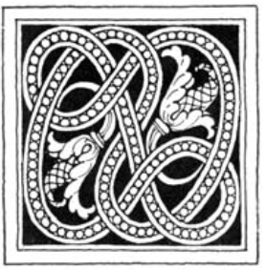
The designer Claude Bragdon used the 3x3 magic square to make a beautiful design. What mathematical property does the design have? (Slide 8.)
Copyright free.
Claude Bragdon, Frozen Fountain, 1932
You can rotate the design to show that it exactly fits on top of itself twice in 360⁰ - in the starting position and halfway round.
The design has rotational symmetry order 2.
Draw attention to the fact that it does not have reflective symmetry.
Ask the pupils, using a copy of Dotty squares with numbers for tracing and a coloured pencil and tracing paper, to join the dots in number order.
Now choose a rotation of your first square (use the second Dotty square with numbers for tracing) and repeat using a different colour. Repeat for the other two rotations. What do you notice about the four designs?
They should all be rotations of each other with just two distinct orientations. This happens because the rotational symmetry is order 2.
Now they carefully copy the two distinct orientations across onto the blank square.
Colour in the design making sure you keep the rotational symmetry.
When the design is complete, they can make a list of the different shapes they can see in the design.
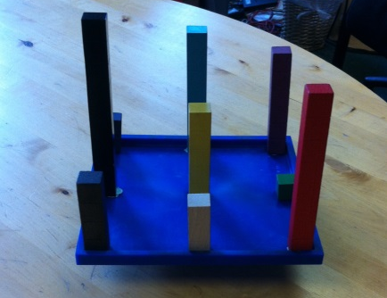
Investigation 3
As shown in Slide 10, the Luo Shu square physically balances. Suitable equipment like Multilink cubes or lego/duplo and a platform will be required. It is very hard to balance by hanging from a string or balancing on a sharp point, so using something such as the outer surface of half a potato, is advised. Slide 10 provides an illustration of one way of setting this up.
Pupils may be intrigued to multiply the "weights" by their distance from the centre and then compare what these add to on either side of each line of symmetry.
The Luo Shu magic square is also used in Feng Shui. The pupils can use a compass to find out which direction is north (they could take the average of several readings taken in different places). Taking a print-out of Slide 11, they orientate it correctly so that number 9 in the square faces south.
What kind of displays, and of what colours, might best be positioned in which parts of the classroom, according to Feng Shui practice?
Sometimes the Luo Shu square is called the 9 Halls diagram. It was believed that a different family lived and farmed in each of the 8 outer squares but they shared the central square (it also refers to emperors and palaces on earth and in heaven). Some people also use it to help find out if different areas of their lives are in balance, whether they visit each of the nine halls.

Task 3: Exploring and creating 4 x 4 magic squares (approx. 1 hour)
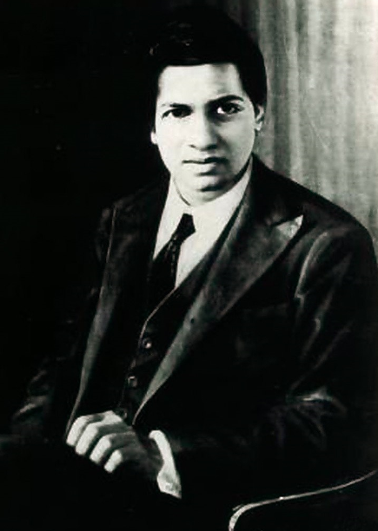
As well as ancient China, magic squares have been used in ancient Egypt and dating back over a thousand years in India, Persia, Arabia and Europe. An example is given in slide 12 from India. Ask pupils if they recognise any of the numbers (they should recognise the 2, 3 and 0 and possibly the 1). The numbers used are 1 to 16.
Copyright free.
https://upload.wikimedia.org/wikipedia/commons/c/c1/Srinivasa_Ramanujan_-_OPC_-_1.jpg

We have identified 0, 1, 2 and 3.
The magic number for this square is 34.
We can work out what all the other digits are. See if you can solve the puzzle.
(Use the magic number to find 6, 8 and 15. The latter gives us 5. We now have 4, 7 and 9 to find. One of these must be in the top left hand corner. 17 and 19 are not in the square so it must be 14. Use the magic number to find 7 and 9.)
Slide 13 shows another magic square, this time from North Africa. Ask pupils if they recognise any of the numbers (they should recognise the 1, 7 and 9). Once the western numerals are revealed, ask pupils to work out the magic constant.
Look carefully at the numbers used in this square and discuss in your groups why the magic number is different this time.
Slides 12 and 13 can be printed out as task sheets for each small group. Slides 14 and 15 illustrate how we got the numbers we use in the west today. Taken together, these four slides can be used to develop the pupil's historical and inter-cultural knowledge.
A more recent Indian mathematician, Srinivasa Ramanujan (Slide 16) who died just a hundred years ago, came up with a formula for creating one’s own personal magic square. Using squared paper, invite pupils to make their own 4 x 4 magic squares starting with their own dates of birth following Ramanujan's method.
Using Ramanujan's own birthday, the steps are explained on slides 17, 18 and 19. Pupils can be supported in following these steps. They can then test their squares to check that they are indeed magic.
What patterns do you notice (Slide 17) in the construction of the magic square?

It is likely that some pupils with different dates of birth have the same magic number.
How is this possible?
After looking at Slide 20, a possible homework task is for pupils to find out how many ways they can reach their magic square’s magic constant.
Ramanujan (Slide 16) was an interesting figure and his life and experiences raise important issues about colonialism and the clash of cultures. Details can be found at https://en.wikipedia.org/wiki/Srinivasa_Ramanujan which also includes the famous tale related to the number 1729. Some pupils may be interested to work out the numbers involved for themselves.
A possible extension activity is to introduce a 4 x 4 square made of words (Slide 21).
Pupils can be asked to what extent it is a magic square.
Task 4: Latin squares (approx. 1 hour)
The Swiss mathematician Leonhard Euler was working on magic squares when he came up with the idea of a square in which every number or symbol appears as many times as the size of the square but only appears once in each row and column (Slide 22).
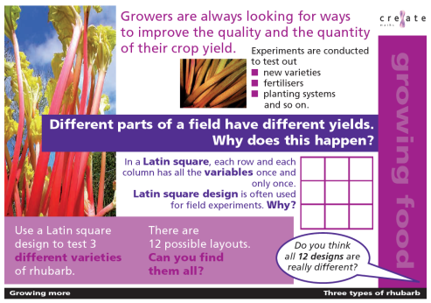
This became known as a Latin square because in the first versions Latin characters were used as symbols. (Latin squares were also created during Task 1 (Slide 3)).
Latin squares are very useful today in planning sports fixtures, timetables or experiments. (See http://www.cre8atemaths.org.uk/growing-food/growing-more for further ideas about their use in agricultural experiments.)
http://www.cre8atemaths.org.uk/growing-food/growing-more
They also form the basis of the Sudoku puzzle popular in many newspapers and magazines today.
Step 1
A good Sudoku is one that has a unique solution. Slide 23 shows three different starting points for constructing a Latin square. Two are good Sudukos but one has more than one solution.
Which is which?
Find three more different Sudoku starting points using two numbers.
When the pupils feedback their ideas, there will be an opportunity to discuss what is the same and what is different mathematically. It is important to emphasise that there are no "right" answers and that these are the sorts of decisions that mathematicians make as part of their thinking.
Think about your decision. What are the possible options?
Commit yourself to your choice.
Justify your choice … and reflect on your choice when you have heard the views of others.
Ask pupils to work in pairs to complete the puzzles on the worksheet Sudoku 1. Explain the rule that each of the blocks also has to contain all the digits being used within its squares. Each number can only appear once in a row, column or box. One piece of advice to give, if required, is to start with the row, column or box with the most numbers already in place.
Further Sudokus can be downloaded from the internet for pupils who enjoy the task (see Other Resources below).
Step 2
A second activity which pairs can work on as they finish Sudoku 1 is to get hold of a whole school timetable or similar plan that works like a Latin square (see an example in Slide 24).
Sudoku solution to Slide 25
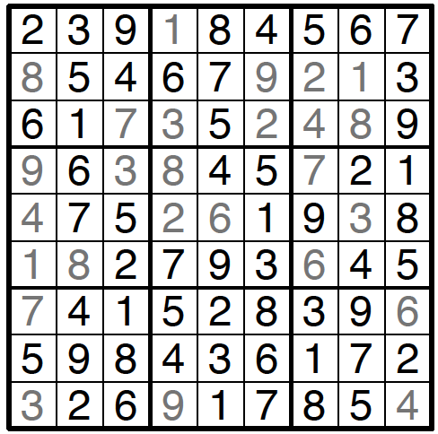
Imagine a school day split into four lessons with four different classes and four different teachers. Construct a timetable.
Step 3
Finally, the class can try a challenging Sudoku (Slide 25 and Sudoku 2). One approach is to have the children working in groups with each group in turn suggesting a next number to fill in. The group needs to justify their entry to the class. This will provide rich opportunities for argumentation and mathematical communication.
http://www.printmysudoku.com
After each group has had at least one turn, the groups can continue to work independently. If they have a laminated wipeable copy of the Sudoku with which to work, they can easily then go back to the half-solved version of the puzzle and begin again from there.
Task 5: Vedic squares (approx. 1½ hours)
Introduce an extract of a Vedic square (Slide 26). Vedic squares have been used for many centuries in India and across the Islamic world to create geometric patterns for tiling. What do pupils notice about the sequences by which the numbers go up in the beginnings of the rows (and columns)? It seems to be a multiplication square.
But where do the 3s and the 7 in the bottom right hand corner come from?
Allow the pupils to discuss the problem in pairs before continuing.
3 x 4 = 12 → 1 + 2 = 3
3 is the digital route of 12. What would be the digital route for 7 x 8?
Give out copies of slide 27 and pupils work in pairs to fill in the missing numbers. These can then be revealed for checking. What patterns in the number sequences do pupils notice?
This task can be extended by colouring and cutting out more copies of their chosen tile and sticking down the tiling pattern to make a display.
Other tiling patterns from the Vedic square can be explored using square dotty paper - this is considerably harder.
Once the Vedic Squares have been completed, pupils can use The Vedic square, rulers and different coloured pencils to experiment by joining numbers together (as illustrated by slides 28 – 29).
Pupils go on to colour their shapes using different colours. Working in a small group, they choose one of the tiles and cut them out and experiment to see if they fit together to make a tiling pattern or tessellate with other shapes. What do they notice?
Task 6: Further exploration of magic squares (approx. ½ hour)
There are very many more quite magical things to be discovered about magic squares. Slides 30 to 45 explore a few of these ideas. The torus (useful in electrical engineering as the shape offers least resistance to electricity) can be formed from larger magic squares (9x9 or 27x27) (Slides 32-33). Patterns of the frequencies (or ratios) in relation to each of the Pythagorean musical scales can be found in a 27 x 27 magic square (Slides 34-35). Nearly 1,500 years ago, Varahamihira from India described a magic square for making perfumes (Slide 36). Many intriguing patterns can be found by colouring magic squares (Slides 37 to 41). A short video (https://www.youtube.com/watch?v=hIgmiDnmVdU) gives breath-taking images of Chladni acoustic patterns which can then be compared to patterns in magic squares. Finally, work on measuring water retention patterns by magic squares is briefly introduced (Slide 44). With adequate lego and time, this could lead into a practical investigation.
Steps in a P4C Enquiry
1. Preparation (warm-up)
2. Presentation of stimulus (video)
3. Thinking time (reflection)
4. Conversation
5. Questions (formulation)
6. Airing (of questions)
7. Selection (voting for a question)
8. First Words
9. Discussion (building) – creative, critical, caring and collaborative thinking to find some answers to the question.
10. Last Words
11. Review (of enquiry)
Task 7: A Philosophy for Children (P4C) enquiry (approx. 1 hour)
Following the first activities, explain that throughout history and nowadays, many people have thought, or think, that numbers can have special meanings and power. There seem to be some very interesting harmonious patterns that come out of magic squares (see video: https://www.youtube.com/watch?v=Y8SA0gtSBNs).
The pupils will need to know that much of the mathematics in the video is very advanced and will be beyond them but that they will be able to catch glimpses connected to the mathematical work they have been doing with magic squares. (An alternative video which looks at number patterns in nature can also be used to stimulate a P4C enquiry - http://www.etereaestudios.com/docs_html/nbyn_htm/intro.htm.)
Use the video to generate questions that might be used in a P4C enquiry.
Extending the learning
A challenging extension which may require the teacher and pupils to work together is a magic square Sudoku: http://www.sachsentext.de/en/node/825. The 3x3 magic squares will be versions of the Luo Shu square (Slide 6). How do you know?
A simple method for making odd numbered magic squares, together with a general magic square formula, can be found in slides 48 – 50 (currently hidden).
A lovely though challenging investigation is to create and test out a Geomagic version of the Luo Shu magic square using polyominoes made from Multilink cubes, or similar equipment or just squared paper. This is based on the work of Lee Sallows. Slide 47 illustrates how this can be set up and provides some of the solutions. Pupils can be asked to note the correspondence between the shapes and the minuses and pluses in Slide 7. This could also be included in the magic square investigation activities in Task 2.
Other resources (material and human resources)
For Sudokus using less than a 9 by 9 grid try http://www.mathsphere.co.uk/resources/MathSphereFreeResourcesSudoku.html which also has very much more difficult puzzles available. A suitable website for further 9 by 9 grid Sudokus is http://www.printmysudoku.com using the ‘easy’ level.
It is advised that teachers should have training before conducting a P4C enquiry. Further information about P4C can be found at https://www.sapere.org.uk.
Ethical issues or dilemmas
There is a very low risk that a pupil might see or create the Swastika pattern as a result of following the number sequence around a Luo Shu square (Slides 9 and 31). If this occurs then it is best to explain that this is an ancient eastern symbol that has nothing to do with Nazi Germany. (In the actual Nazi symbol, adopted following the discovery of Swastika symbols in the remains of ancient Troy, the arms are reversed to the traditional version and it is used at an angle.)
Throughout history and nowadays, many people have thought, or think, that numbers can have special meanings and power. ‘Magic Squares’ may have been so named because people were amazed by how the positioning of certain numbers in certain ways led to the same result whichever way numbers were added together in a line and some have thought that supernatural forces were at play. Of course, as the unit indicates, there are mathematical explanations for why they work, to do with number bonds and balance, which mean that the squares should not be called ‘Magic’ without explanation (especially where there may be pupils present from certain religious backgrounds who might hold negative associations with the term).

