MAPPING OUR WORLD WITH MATHEMATICS
Description
The activity explores the history of European colonisation through studying maps and globes. It considers the way in which the earth can be measured - distance, area and so on and addresses how maps as spatial representations can intentionally or otherwise mislead us in our view of the world.
The activity has seven tasks.
Global citizenship competences addressed
- capacity to examine global issues
- appreciate different perspectives & world views
- analytical & critical thinking skills
- communication & co-operation skills
Global citizenship content
Inequalities and hierarchies; the legacy of colonialism; seeing our local country in its historical and geographical place in the world; intercultural relations
Mathematical approaches
- looking for patterns and connections
- asking yourself questions
- conjecturing and checking things out
- using embodied and multi-sensory approaches
- using representation and symbolism
- modelling and dealing with uncertainty
- using argumentation and reasoning
- recognising the political and ethical dimensions of mathematics
Mathematical content
Area, length, angle and properties of circles on a sphere - equator, pole, latitude and longitude. Large numbers, percentages and bar charts read, compared and interpreted. Decimals and ratios.
Resources required
For each small group: an inflated globe (all the same size to support class discussion); a piece of string longer than the circumference of the globes; a set of Getting to know our partners cards; an A3 laminated copy of Map 1 Slicing the globe, Map 2 Squashing the globe, Map 3 The Mercator map, Map 4 The Peters map, Map 5 The Mercator 0º map and Map 6 The Kiwi map; tracing paper; washable colour pens, ½ cm squared paper, postcards; a laminated A4 copy of The Mercator continents, Land mass and population of the seven continents and Graph comparing land mass and population of continents chart and cards; a worksheet copy of The world's population represented by our class. For the class: one large copy of the Peters map.
Time needed (in and out of the classroom)
Approximately ten hours curriculum time
Organization and practical issues
The children will work in groups of six and as a whole class. If the children are not used to working in groups, adapt the activities to work with groups of three.
Suggested plan for teaching
Task 1: Getting to know the globe and each other (approx. 1 ½ hours)
Copyright free. Authored by Colin Jackson
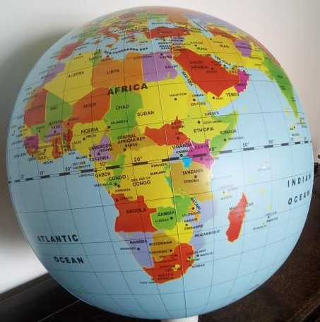
Give each small group an inflated globe. Globes usually spark intense curiosity in children so give them plenty of time to explore informally. They can ask each other questions as they explore and play. You may want to prompt them to think about where their parents and grandparents were born.
There is an opportunity to open up a philosophy discussion here.
What questions can we ask about what we see?
Collect together questions from each group, one at a time, until all the questions are recorded. The children then vote for the question they would most like to discuss and a whole group discussion follows. (See Task 7 below and the PiCaM teacher professional development materials for more information about how to run such a session.)
Which of these questions can we use mathematics to explore?
Explain that they are part of a European project involving Romania, Portugal, Greece, Germany and the UK. Can they find all five countries on their globe?
Explain that the globe tells us the relative size of countries - which countries are bigger and which countries are smaller - and the relative distance between places. It also shows the shape of countries. Put the globe to one side.
Give each group a set of Getting to know our partners cards. Each child is dealt a statement card which they do not show the others. The other ten cards are face up on the table. The puzzle is to match the ten cards in pairs. The children read out their cards in turn without showing the card to the rest of the group. The rest of the group will need to listen carefully. After each of the cards has been read once, the group can ask for any cards of their choice to be read again. Some are irrelevant and some are needed to solve the puzzle.
Does the result surprise you at all?
When the puzzle is solved, they check their solution by studying the five countries on the globe. Each group takes a photo of their solution.
How far are these countries from each other?
Use the string to compare distances between the five capital cities. What questions can they ask and answer? If appropriate, give the scale factor for distances on their globe (for example, for a 40cm diameter inflated globe the scale is approximately 1cm represents 320 Km) or encourage them to calculate this themselves if appropriate.
 Each group writes down some things they have learnt. These reports can form the basis for an eTwinning exchange. You may like to extend the activity by comparing the distances between the places where the children's parents and grandparents were born.
Task 2: Comparing colonies (approx. 1 hour)
Now we are going to look at pairs of countries on the globe. Which is bigger - Algeria or France? India or the UK? Namibia or Germany? Brazil or Portugal?
A colony is a country ruled by another country and occupied by settlers from that country.
Give the children time to find these places on their globes. Ask them to write down which is the bigger country in each pair. For example, Algeria is bigger than France.
Explain what a colony is and that many European countries had colonies. In each of these pairs, the first country was a colony of the second. In every case, the colony is bigger.
What are some of the similarities between the colonising countries and the colonised countries?
Explore what the children know about any of these countries and other colonies. Draw out where appropriate the legacies of colonialism - for example, language; current tension or conflict; aspects of cultural heritage; wealth distribution worldwide; patterns of discrimination.
Ask the children to identity on their globes the poles, the equator, lines of latitude and lines of longitude.
Use the string to compare the lengths of the equator, the lines of longitude and the lines of latitude and to write down what they discover.
Why does the 0º line of longitude go through London? Why is the North Pole at the "top"?
Draw out that these are legacies of European power. Explain that this history affects the way we see the world.
Task 3: Mapping the globe (approx. 1 ½ hours)
We are going to explore how maps of the world can both tell us things but also sometimes mislead us.
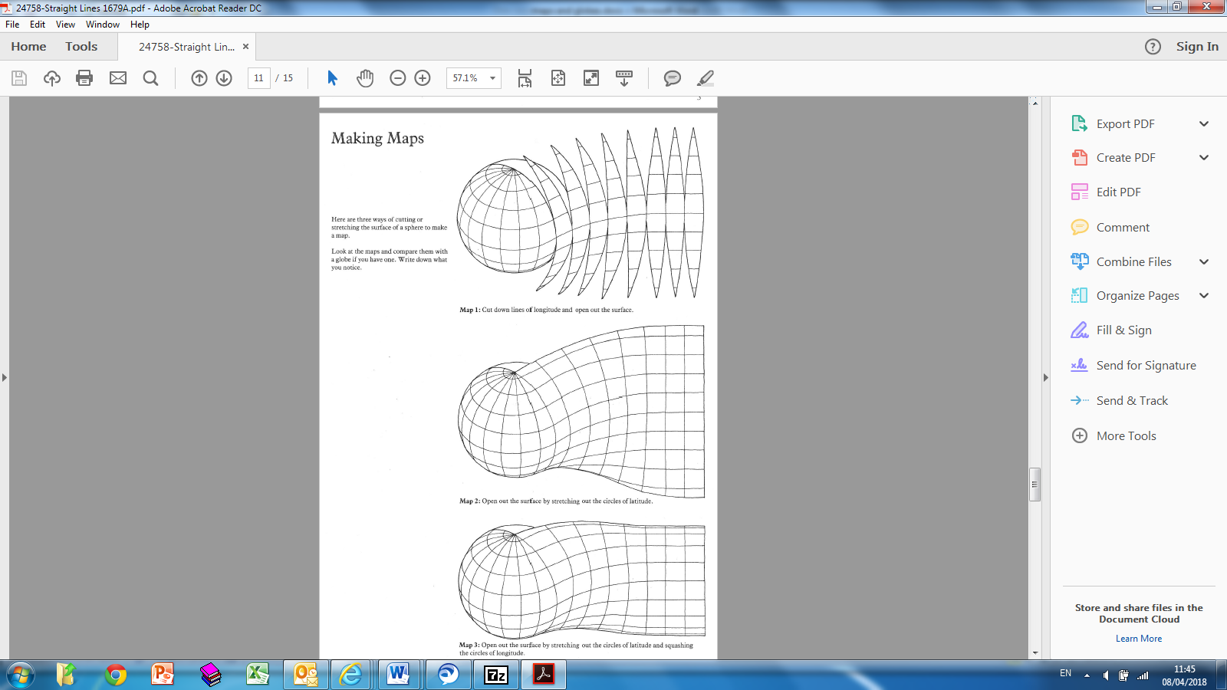
To make maps, we have to move from a curved surface to a flat one. Why would people want to do this?
From Smile 1679. Copyright free.
Downloadable from https://www.stem.org.uk/
Show the image of creating a nearly flat surface from a globe.
Give each small group an inflated globe and a copy of Map 1 Slicing the globe.
This produces a sort of a map. What does this map tell us?
Draw out that, for example, we know that Georgetown (Guyana), Accra (Ghana) and Mogadishu (Somalia) are about the same distance north of the equator. They can check this on their globes. Also, that London (England) is more or less due north of Accra.
But what is difficult to see?
Draw out that it is difficult to visualize Greenland or to work out how to travel from London to Murmansk, again making use of the globes for comparison.
Give each small group a copy of the other five maps. Ask the children to discuss in their groups how the maps have been made.
In what ways is each map like the globe and not like the globe? Think about lines of latitude, lines of longitude, how near and far countries are from each other, directions and so on.
Circulate amongst the groups and draw out that Map 2 Squashing the globe is made by cutting the globe in half along the equator and squashing the two pieces flat. The rest of the maps are made by initially making a slice down a single line of longitude. Map 3 The Mercator map is sliced at 180º and made by stretching out the circles of latitude and the circles of longitude at the top and bottom and Map 4 The Peters map is sliced at 180º and made by stretching out the circles of longitude and squashing the circles of latitude at the top and bottom. Map 5 The Mercator 0º map is the same as Map 3 but with the initial slice in a different place and Map 6 The Kiwi map (why this name?) is the same as Map 4 but with south at the top.
Write down some of the things that you notice.
Task 4: Which map is best? (approx. 2 hour)
The Mercator map was published in 1569 and was used throughout the European colonial period. It shows Europe as much bigger in relation to the southern continents (Africa, South America and Australia) than it really is. It is excellent for nautical navigation because it preserves direction.

Which do you think is the best map? Take time to think on your own and make a decision. Think about which is best and commit yourself to an answer.
Choose six places around the classroom and designate them Map 1, Map 2 and so on. Ask the children to move to the place for the map they have decided is the best. At each location, the children discuss why they think their choice of map is the best. They then justify their choice to the rest of the class.
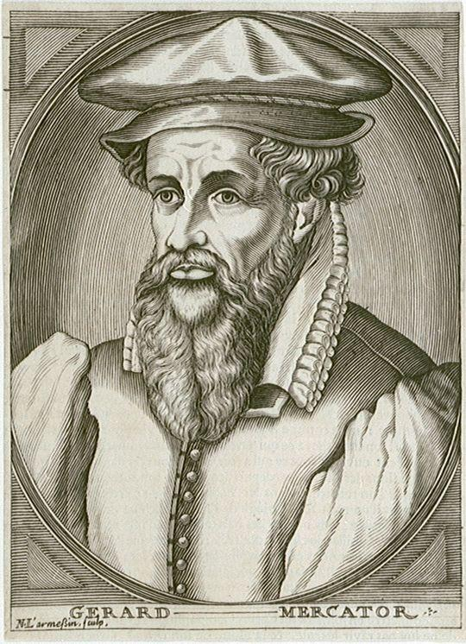
Does anyone want to change their mind? We'll reflect again at the end of the lesson.
Copyright free.
Downloadable from htps://www.rmg.co.uk/national-maritime-museum
Each of these maps is useful in some ways but not in others.
For example, Map 1 is best for reminding us that maps are all approximations. Why?
And Map 2 is best if you want to think about flying from London to Japan? Why?
1. Starting with the globe, the children choose a few countries and compare their shape with the maps.
Which are best for showing the shape of the countries? (Maps 3 and 5.)
2. Ask the children to stretch the string on the globe from Georgetown to London - the direction a sailing boat would need to take. Ask them to notice the angle the path makes with due north. Now repeat on the maps.
Which map gives the correct direction to sail east/west across the seas?
Which map gives the correct direction to sail east/west across the seas? (Maps 3 and 5.)
Discuss when Map 3 was made and by whom and draw out that this was the beginning of European global exploration which later led to colonialism.
3. What can we learn from Map 5? Does Map 6 make you think about the world differently?
This links back to the earlier discussion about the dominance of Europe in earlier times and the consequences for how we see the world today.
But we haven't thought yet about the size of countries.
Use the video at https://www.good.is/articles/map-of-the-earth-is-kinda-wrong which shows some powerful images of the limitations of the Mercator map and shows clearly how the map affects our perceptions of the world. The video is quite fast and packed with information. You may prefer to use the tool on which it is based (www.thetruesize.com) and make some comparisons that you and the children choose.
Give each small group tracing paper, some ½ cm squared paper and washable colour pens.
Trace Greenland and India on your globe. How can we compare their size? Lay the tracings over the squared paper and count the squares.
The children will find that the globe tells us they are more or less the same size. They will need to record their results and this conclusion for use later.
Ask the children to share out the six maps and on each one find and colour Greenland and India.
The Peters map was published in Germany during the 1970s and is promoted by UNESCO. It preserves are so countries and continents are more realistically portrayed.
What do you notice? Which maps are best for keeping the relative size of countries accurate?
Now we know our maps a little better, would anybody like to change their choice of which map is best?
Encourage the children to share ideas and to listen carefully to each other. You may want to repeat the exercise involving the children in moving to their chosen map, perhaps this time allowing them to stand between maps. If the choice comes down to two, they could stand along a line between them indicating their reflections and preferences in a more subtle way.
Write down your final choice and the justifications for your choice.
Once the children are confident about what they want to say, they can record their choice and arguments on a post card and these can then be grouped and displayed alongside a copy of the map of their choice as a poster. They can share their choices and the reasons for them with eTwinning partners.
Task 5: The true size of continents (approx. 1 ½ hours)
Give each small group a globe and copy of The Mercator continents and ask them to order the continents based on the areas on the map. Now ask them to look at the continents on the globe and order them in actual size.
Show the large Peters map. Draw attention to and help the children name the continents. Discuss how a continent could be defined and explain that, for example, some people count Europe and Asia as one (Eurasia) and some people count the Americas as one. Explain that these are conventions; there is no right or wrong answer.
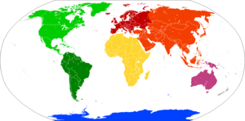
Color-coded map showing the various continents. Similar shades exhibit areas that may be consolidated or subdivided.
Four continents | Afro-Eurasia |  |  | America |  | Antarctica | Australia
Five continents | Africa | Eurasia |  | America |  | Antarctica | Australia
Six continents | Africa | Asia | Europe | America |  | Antarctica | Australia
Six continents | Africa | Eurasia |  | North America | South America | Antarctica | Australia/Oceania
Seven continents | Africa | Asia | Europe | North America | South America | Antarctica | Australia/Oceania
The term Oceania refers to a group of island countries in the Pacific Ocean. Pacific islands with ties to other continents (such as Japan, Hawaii or Easter Island) are usually grouped with those continents rather than Oceania.
Creative Commons Attribution-Share Alike 4.0 license.
Civciv5, Map of the seven continents. Downloadable from:
https://en.wikipedia.org/wiki/File:Seven_continents_Australia_not_Oceania.png, CC-BY-SA.

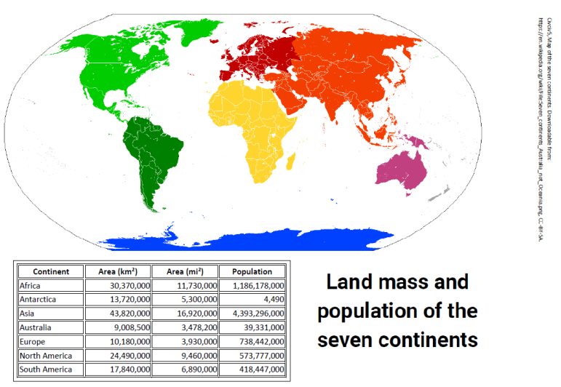
Ask the children what arguments are there for how we divide up the world. Ask which they think is the best and why.
Show the large Peters map again.
Which is bigger, Europe or Australia? Roughly how many Europes fit into Africa?
Encourage the children to share different observations arising from the exercise, the Peters map and their globes.
Ask them to consider and reflect on which continents appear bigger than they are and which smaller.
Civciv5, Map of the seven continents. Downloadable from:
https://en.wikipedia.org/wiki/File:Seven_continents_Australia_not_Oceania.png, CC-BY-SA.

Why might this be important? What mistaken ideas might we have?
Give each small group a copy of the Land mass and population of the seven continents and Graph comparing land mass and population of continents chart and cards. They use the information to place the names of the continents below the graph.
Remind them that they will need to listen very carefully to each other.
When they have completed the puzzle, they can take a photo of their solution.
As they finish, ask each group to write down some questions connected to the graph. Collect together questions from each group, one at a time, until all the questions are recorded.
Which of these questions can we use mathematics to explore?
Each group then chooses which questions to try to answer.
Task 6: Representing the world with our class (approx. 1 ½ hours)
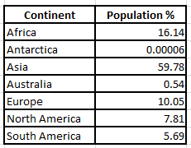
Display the information in the table showing the percentages of the world's population for each of the seven continents.
This table gives the percentage of the world's population by continent. They are in order of size.
Percentages tell us how many out of …?
If there were 100 of us in the class and we represented the world, how many of us would be from Asia? 62. How many would be from North America?
Discuss rounding with the class and decide that 8 is the best answer
In every 100 people, half a person lives in Australia! How could we express this so that it sounds more sensible? (1 person in every 200).
We are going to represent the world's population by using 25 members of our class.
Extension question
The mathematics is more complicated to find a way to talk about the people in Antarctica. This is a hard problem and you will need to work together to try to puzzle it out.
Ask the children in groups to try to find a good way of expressing this. You may need to remind some of the groups that the table shows that in every 100 people, a hundredth of a person lives in Antarctica.

We are only 25 so we need to divide by four. Why? Each of us will represent 4%.
continent | population % | divide by 4 | rounded
Africa | 16.14 | 4.035 | 4
Antarctica | 0.00006 | 0.000015 | 0
Asia | 59.78 | 14.945 | 15
Australia | 0.54 | 0.135 | 0
Europe | 10.05 | 2.5125 | 3
N. America | 7.81 | 1.9525 | 2
S. America | 5.69 | 1.4225 | 1

The information and calculations required are shown in this completed copy of the worksheet The world's population represented by our class. Give each group a copy and work with the groups to help them complete their copy of the table.
Move to a large space, chalk 7 large loops on the floor and then the children occupy these "continents" in appropriate numbers. Any children left over take photographs to record the event.
Conclude the activity by asking the children to discuss in groups what they have learnt from the project and to share this with the whole class. Each child should then write or draw or photograph about something they have learnt. The group then combine these to make a poster.
Task 7: Reflecting on mapping our world (approx. 1 hour)
Alternatively, you may wish to create a P4C discussion using the overall project as the initial stimulus: what questions arise for you from the Mapping our world with mathematics project?
Working in their groups, the children decide on that they would like the class to discuss. The children sit in a circle and each group's question is shared with the class. The class vote on the question they would like to start by discussing - you may like to do this by the children standing facing out and indicating their choice by thumbs up behind their back. A class dialogue then follows. The dialogue will be more like building something together than exchanging ready-made opinions - the P4C teachers' guide (https://p4c.com/about-p4c/teachers-guide/) has many ideas about how to facilitate this. Focusing throughout on collaborative, caring, creative and critical thinking and vocabulary will support the development of critical citizenship and global learning skills and dispositions.
Extending the learning
Possible extensions are: exploring further questions raised by examining the globe in the first task; studying the history and current state of a chosen colony following discussions in the second task; studying the history of the nation state and discussing groups marginalised by the concept, for example, in Europe the Roma and the Sami; representing the data from the third task in other ways, for example, by pie charts.
Other resources (material and human resources)
Depending on what is available in your locality, you may like to arrange a visit to a cultural centre related to a previous colony. Many museums also deal with the topic in informed and sensitive ways.
A similar activity in Greek can be found at https://www.demopaideia.gr/wp-content/uploads/2017/11/enas-kosmosTELIKO.pdf. Oxfam have a resource called Mapping our world. You may find useful some of the images from the activity The globe unwrapped. https://www.oxfamblogs.org/education/mapping_our_world/mapping_our_world/l/home/index.htm.
Ethical issues or dilemmas
Colonialism is a political topic that is painful at the personal level and many freely available resources contain graphic and distressing images that may also undermine the stature of colonial people. It may be that some of the children need support in challenging vestiges of colonial thinking.

If you are using the materials after the project finished, choose some other way of finding a small number of European countries. You might do this through e-Twinning.
This task and the next one draw significantly on SMILE 1679 Spheres. This material is freely available to copy at https://www.stem.org.uk/

