MATHEMATICAL BODIES
Description
This activity is designed to build a learning group where everybody matters and everyone has an equal role to play. It offers an embodied experience of multiples and factors, common multiples, primes and co-primes.
The activity is in four parts: Making the circle and working together; Exploring common multiples; Jumping numbers; Throwing the wool.
Global citizenship competences addressed
- positive interactions with people who are different
- take constructive action for social well-being
- communication and co-operation skills
- conflict resolution skills
Global citizenship content
Inequalities and hierarchies, Buen ViVir (social ecological integration)
Mathematical approaches
- looking for patterns and connections
- asking yourself questions
- being organised and systematic
- being resilient and flexible
- conjecturing and checking things out
- visualising, imagining and using intuition
- using embodied and multi-sensory approaches
- using argumentation and reasoning
Mathematical content
Multiples, factors, common multiples, primes and co-primes
Resources required
For each small group: a laminated number line up to at least 60, preferably up to 100; a large sheet of paper and a suitable marking pen; either one computer between each small group and electronic worksheet from http://tube.geogebra.org/material/show/id/1385121 or a supply of 10-point, 12-point, 13-point and 20-point circle worksheets
For the whole class: a bean bag; a ball of wool which will unravel easily, a zero hat or label
Time needed (in and out of the classroom)
Approximately four hours curriculum time, half in the classroom and half in a larger space.
Organization and practical issues
The emphasis in this activity is on everyone working together but for some of the tasks the children will work in small groups. Many of the tasks can be used throughout the year at any time when concentration and awareness of the ensemble needs re-establishing.
Suggested plan for teaching
Task 1: Making the circle and working together (approx. 1 hour)
The circle makes everyone equally important. And everyone can see everyone else.
We are going to work as an ensemble, which means working all together and thinking together. If the activity goes wrong, it's everyone's responsibility.
Put a bean bag on floor. Ask people to stand so that everyone is standing exactly the same distance from the bean bag.
What is the shape we have made? Why does it make a circle?
Why might it be a good shape for working together?
Ask the children to check that they can see everyone. Move the beanbag and re-form the circle.
Have we made a circle the same size as before?
Ask the children to see everyone at once without moving their heads. How this is possible? Help the children to realise that by not looking at anyone special we can put everyone into our peripheral vision.
Ask everyone to put their hands in the air at exactly the same time. Explain that someone watching should not be able to see anyone “leading". Do this as many times as you like. The group will quickly get better at it. Remark on this.
What do you notice? What do you feel?
Can we all clap exactly together?
Repeat as necessary. Reinforce that this is thinking together.
Now we are going to explore the whole space.
The group walk gently and slowly round the space in silence. Not in circles, and not with anyone else. They should imagine they are alone, and not look directly at anyone. They should try and keep the whole group in their peripheral vision, so that they “know” where everyone is. Then, by thinking and working together, find the exact second where everyone stops together. Stress the idea that if they really try hard to work together, the stopping is “magic”. Then move to them both stopping and starting together.
What do you notice? What do you feel? What do you like? What do you not like?
And now, from where we are, can we again all raise our hands exactly together?
All sit in the most beautiful circle. Establish a simple beat. All count together, clearly but quietly. To perhaps 15.
Count again to 24. This time, all raise both hands on every multiple of 2. Count again to 30. This time, all raise hands on every multiple of 3.
Count again to 36. This time, half the circle raise their hands on multiples of 2, the other half on multiples of 3. Ask the children to discuss these questions with their neighbour:
Are there numbers at which we all raise our hands together? Which are they? Why?
All hands are raised together first when the lowest common multiple (LCM) of the numbers is reached. After that, all hands are raised together on multiples of the LCM. You may need to repeat this exercise several times until all keep the rhythm all together. Now try swapping the two groups over.
Count to 60. This time all raise hands on multiples of 5. Count again to 60. This time, a third of the group raise hands on multiples of 2, 3 and 5. Repeat as necessary.
Discuss with your neighbour: When do we all raise hands together? Why? If we counted in 3s, 4s and 5s, when would we first be all together? Why?
Finish the task by standing up, and all raising hands together.
Task 2: Exploring common multiples (approx. 1 hour)
All sit still and quiet with empty hands. Hands together on the table or in laps.
Without moving your head, be aware of how many people you can see. Unlike the circle, it will not be everyone. Does that mean you can't all raise your hands together, like you did in the circle? Try it and see.
If it worked, ask: how was that possible?
Establish a simple beat and repeat some of the earlier hand raising exercises. Finish with a count of 36 with half the circle raising their hands on multiples of 2, the other half on multiples of 3.
When did we all raise our hands together? These are called common multiples. Tell me a common multiple of 2 and 3. And another. And another. And another …
Draw out that these numbers are common to both times tables. All hands are raised together first when the LCM of the numbers is reached. After that, all hands are raised together on multiples of the LCM. The LCM of 2 and 3 is 6.
Which number is the first time we are all together?
2 x 3 = 6 3 x 2 = 6
Repeat the exercise until all keep the rhythm all together.
Count to 60. This time, half the group raise hands on multiples of 4 and half on 5.
Discuss with your neighbour: When do we all raise hands together? Which number is the first time we are all together?
20, 40 and 60 are common multiples of 4 and 5. Why do we think we call them common multiples?
4 x 5 = 20 5 x 4 = 20
Ask the children what the rule appears to be. At this point, the children are likely to suggest you just multiply the two numbers together.
This is a conjecture. It's a good idea. It certainly seems like it but we don't know yet if it's correct. We are going to find out.
Smile 0895. Copyright free.
Downloadable from https://www.stem.org.uk/
Show the image below. 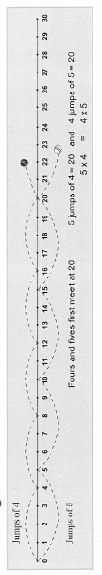
Discuss the jumps to 20 and how we can see the common multiples.
The idea of conjecture is a very rich and deep idea and fundamental to doing mathematics. This lesson offers an initial experience of the idea - expect that the children will need to have many similar experiences before beginning to grasp what is meant.
Give each group table a laminated number line up to at least 60, preferably up to 100. Using the laminated number line and felt pens, the children find the next two common multiples of 4 and 5 - 40 and 60 (and beyond if there number line extends). The children then explore the jumps of 3 and 7, 3 and 9, 3 and 4, 4 and 6. They will find that the rule does not work for 3 and 9 or 4 and 6. It helps the children develop the idea of conjecture and to understand the need for proof if they experience things that don't work (even though they seem plausible) as well as those that do.
[When the starting numbers have a common factor, the "rule" for the LCM does not work. For example, the LCM of 4 and 6 is 12 not 24. This happens because 4 and 6 have factors in common.]
The children record in their books the common multiples up to 60 or beyond of the pairs of numbers they have explored and circle the LCM in one colour and the product in another. Encourage them to reflect on why the rule works sometimes but not others. Any ideas can be tested out with new pairs of numbers. Bring the class together and ask the groups to share what they have discovered.
Task 3: Jumping numbers (approx. 1 hour)
The children make a beautiful circle. Starting with the teacher, each person in the class will do one single jump. Repeat but this time jumping in pairs - the first two children, the third and fourth children and so on. Each pair tries to jump exactly together. When the pairs have jumped, ask the group immediately whether the number of the group is odd or even.
Are we a multiple of two? How do we know? If we are odd, is it the “left over” person who is “odd”, or the whole group? If the group is odd, what could we do?
Steer the discussion to the idea of continuing round a second time.
Will you jump with the same person the second time round?
By remaining in or leaving the circle, make the circle odd if it isn't already and jump round twice in pairs. The second time there will be no one left out.
Why? What did you notice? What did you feel?
Steer discussion to the idea that it feels nice to see two people jumping exactly together. Ask how this is possible. Draw out: using eye contact, thinking together, deciding together and so on.
People’s bodies and brains are surprisingly good at thinking and working together.
By remaining in or leaving the circle and having a child observer if necessary, make the circle not a multiple of three and jump in threes. As before, we continue jumping round the circle so no-one is "left over".
How many times did we go round?
It is likely that not everyone will realise that we have to go round three times in order to make a multiple of three. Allow discussion, ask if we would ever have to go round twice if we are jumping in threes and leave the question open at this stage.
How is it possible for three people to jump together? Does it feel/seem/look different to two?
Draw out that we no longer have direct eye contact, so must use peripheral vision and more advanced thinking together. Draw out that to make it easier we can: go more slowly, take time, wait until we know everyone is ready.
Repeat with everyone jumping in fours. Is the number a multiple of 4? If not, go round again. How many times altogether? If the number is even but not a multiple of four, we need to go round twice altogether. If it is odd, we need to go round four times altogether. Adjust the number in the circle so that the children experience all three possibilities.
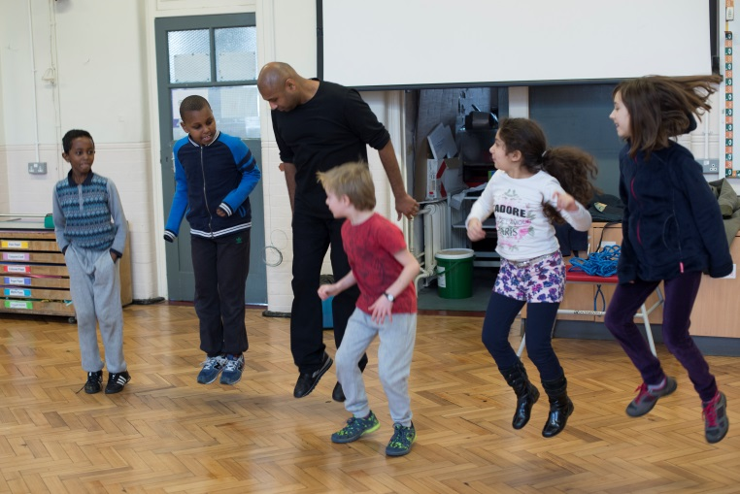
If mistakes happen, which they will, enforce the idea that it is everyone's responsibility. While the group is working together, we must all concentrate all the time so that we can make sure that the right people jump together. Also reinforce that we must take our time and wait until everyone is ready.
© Sarah Ainslie. Permission given to reproduce.
Ask the children in silence to split themselves into three unequal groups. Give each group a large sheet of paper and a suitable marking pen. Explain that they are going to repeat the jumping as before but in their smaller circle. Each time they ask themselves:
Did we need to go round more than once? How many times did we need to go round?
They record what happens on the paper and look for patterns and explanations. What predictions can they make? Call the children back to sit in the class circle. Ask each group to share some of the things they have found out.
Finish with jumping chains, going round the circle in ones, then in twos and then in threes without stopping. This is hard but very satisfying when it works. This task builds working together with concentration and attention. It is an exercise that can be used over the year and great pleasure derived from becoming skilled as group in the smooth and rhythmic pattern making. It can be extended by continuing to higher numbers and by going up and then back down.
Task 4: Throwing the wool (approx. 1 hour)
Ask about 8 or 9 children to form a small circle at the front of the class. Make sure the number of children is not prime and is different from any of the group sizes from the previous task. Choose a factor, F, of the group size. Choose a child to be zero and give them a zero hat to wear.
Starting with zero, ask the children to throw the ball of wool to the person who is F steps round the circle. Zero keeps hold of the end of the wool and the wool unravels around the circle as it is thrown.
What has happened? Did everyone get a turn? How many times did we go round the circle? What shape have we made?
Choose a number, C, which is co-prime with the group size. [Two numbers are co-prime if they have no factor other than one in common.] Starting with zero, ask the children to throw the ball of wool to the person who is C steps round the circle. Zero keeps hold of the end of the wool and the wool unravels around the circle as it is thrown.
What has happened? Did everyone get a turn? Did we go round the circle more than once? What shape have we made?
The children now work in small groups exploring different numbers of points on the circle and different jump sizes. If computers are available, they can freely investigate point circles of their choice. If computers are not available, they can explore 10, 12, 13 and 20 point circles on the worksheets.
Ask and try to answer as many interesting mathematical questions as you can. Make and record conjectures. Try to explain and justify what you find out."
There are many different questions that can be asked. For example:
- What happens with a jump size 1?
- Can I always make the same shape a different way on the same circle?
- When can I make a square? A triangle? A pentagon? And so on.
- When do I visit every point?
- Are there some circles where I always visit every point?
- What sort of numbers are these?
Have these questions in your mind to nudge children if they are finding it difficult to ask their own questions.
A harder question to explore involves counting the number of lines and the number of times round the circle. Again, encourage the children to make predictions and to justify their thinking. This is a rich investigation and you may choose to spend two or three lessons on the task.
Extending the learning
Activities to extend the learning have been suggested above. To aid inquiry, if a suitable space is available, the patterns made in Throwing the wool can be recorded on the floor using chalk. Throughout the activity it is important to provide opportunities for discussion making explicit the links between working together and mutual trust and respect.
Other resources (material and human resources)
Further ideas for embodied work on multiples and factors and also other areas on the mathematics curriculum are available at http://www.embodyingmathsproject.com/.
Ethical issues or dilemmas
In any work focusing of the body, there is a need for sensitivity to issues of diversity, body shaming, disability and other issues of difference. For children using wheelchairs, some of the embodied tasks will work effectively, for example, stopping and starting altogether. For others, for example, jumping together, the task will need adapting in order for it to be inclusive. Stillness, focus and awareness of others, all demanded by this approach, may be differentially available to different children. To maintain mutual respect and the development of the learning community, all mistakes need to be "our" mistakes rather "yours".

These tasks draw on material developed as part of a collaboration between Complicite Theatre Ensemble and Sheffield Hallam University.

