PLAYING AND MAKING MATHEMATICAL GAMES AND CRAFTS: SPACES FOR COMING TOGETHER
Description
This activity provides an opportunity to think about teaching and learning mathematics differently. It creates spaces, inside and outside the school context, for children to collaborate and share experiences amongst themselves and with others through playing mathematical games or making mathematical crafts. The game or the craft becomes a way to access the complexity of living together in the urban landscape; and the mathematics of the game or the craft becomes a way of signifying connections between words, bodies and algorithms.
Global citizenship competences addressed
- appreciate different perspectives & world views
- positive interactions with people who are different
- take constructive action for sustainable development & social well being
- communication & co-operation skills
Global citizenship content
Playing and making as part of who we are and could become in our mathematical worldviews; how we sense self and other; share alternative knowledge systems; connect number and geometry with cultural and intercultural relations; make and exchange skills, competences or ideas with peers and people in the urban landscape.
Mathematical approaches
- looking for patterns and connections
- being organised and systematic
- conjecturing and checking things out
- using argumentation and reasoning
- recognising the political and ethical dimensions of mathematics (as in creativity)
Mathematical content
This will depend on the choice of game or craft. All provide: opportunities to think about rule making, rule breaking and remaking; the politics of algorithmic thinking. The final optional task includes planning, map reading and creating timetables.
Resources required
Access to mathematical games and crafts. Materials (paper in colour, strings etc.) to facilitate the process of crafts making in forms portable and sharable with others.
Time needed (in and out of the classroom)
Approximately eight hours’ curriculum time but very flexible. For some, developing this as a topic rather than within the mathematics classroom may be appropriate.
Organization and practical issues
The activity requires a combination of small group work, workshop and whole class activity. Children and adults will have to capitalize, advance and rely on collaborating and performing with others in the public space either of the school or the community.
Suggested plan for teaching
Rather the spaces created can be organised in open enough forms to sustain otherness, difference and diversity. The emphasis is in sharing the joy and experience of playing and making. Such sharing can be sensed not only between children and adults of the community playing a particular mathematical game or craft making, but also amongst them as the unfolding of life-stories and getting to know each other, ideally in public spaces in the community. Alternatively, the activity can be adapted to be more structured and to focus on more specific mathematical content.
The activity can be organised across 3 main tasks. The first will focus on exploring a small number of mathematical games or crafts, the second will involve the growth of skilfulness in playing a game or making a craft and the third one in sharing their expertise with others in the public sphere of the school or outside in the urban landscape of their community. A number of different possible games, puzzles and crafts are suggested, all of which have mathematical properties. They are not intended to be a definitive list. Rather, they are there to inspire you to find activities that will resonate with your children and your community and to enjoy playfulness.

The eTwinning platform can help students and teachers to share experiences of playing mathematical games and making crafts in their local contexts and explore similar practices amongst youth playing and making cultures across countries.
Task 1: Explore Mathematical Games or Crafts
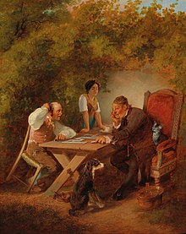
Step 1: Have a number of mathematical games or crafts available for children to experience and explore. As examples, games can be number scripts, dominoes or tangrams and crafts can be making origami, knots, robots and so on. Try to make available 2 or 3 games and 2 or 3 crafts.
Step 2: Children in small groups choose one game and one craft to focus on in more depth. They spend time in learning how to play the game and make the craft (reading instructions, watching video tutorials and so on) and note down what they learned.
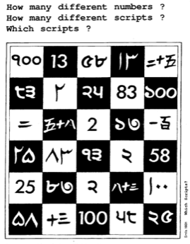
Step 3: In addition, using the internet or other sources, they locate information concerning the cultural grounding or significance of the game or craft they have chosen. Which varied cultures are present in these games or crafts? What are the mathematical skills in number or spatial sense embedded in the process of playing the game and making the craft? How have these games or crafts changed over the years and how are they being used today? By young people, by the market, in industry, in digital culture?
Picture 1: Domino Players
As an outcome of this task a poster can be constructed by each small group to present the games or crafts they have decided to explore, denoting not only the mathematical content in them (for example, dominoes provide an opportunity for a wide variety of number pattern investigations, number scripts develop the understanding of place value, tangrams will develop spatial awareness and can lead to work on area, origami can develop work on similarity and congruence), but also their significance in ancient, nomadic or contemporary cultures.
Picture 2: Different number
scripts

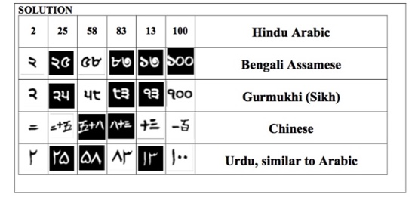
Task 2: Play a game! And make a craft! Become an expert?!
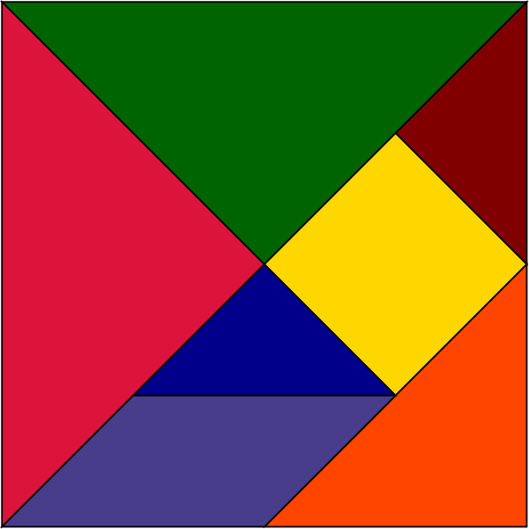
Step 1: As a first step in this task, drawing on what they have found out in the previous task, the children will concentrate on developing their own skilfulness in playing their game or in making their craft. Allow plenty of time for the children to spend playing, working slowly and carefully so that they capture the details of the movements in rules and patterns
Picture 3: The origins of the scripts
Step 2: Children are asked to identify techniques in playing their game or making their craft, as well as, to refine their own attempts in following a technique.
- Focus on your game or craft
- Find the rules
- Find the patterns
Picture 4: The 7 piece tangram
- Identify your technique
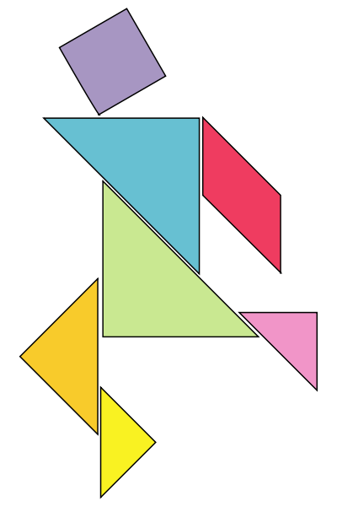
- Refine your technique
- Work in the company of your small group.

In this, the company of the small group will be important so that the refining process happens collectively as a performing process. To refine your techniques in playing and making to become skilful is not an easy thing. Refining is a complex process that might demand work in smaller groups but also individually. It focuses on slowing down the pace of working out the technique, learning to imitate intermediate steps and being attentive in how specific movements contribute to the final outcome. In this step, it is advisable for children to work in smaller groups and learn to appreciate and support each other.
Picture 5: Tangram puzzle (man)
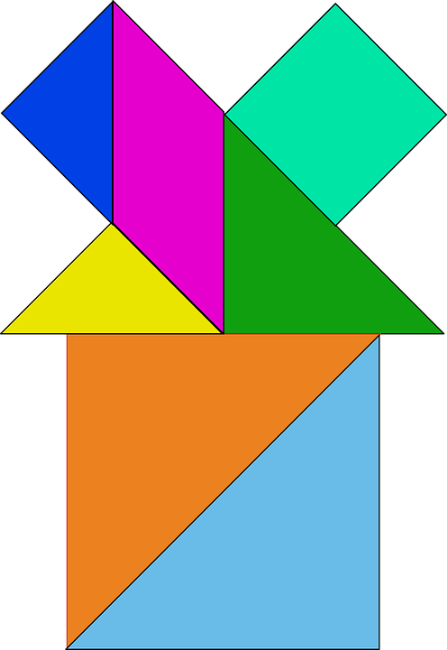
Step 3: What might be the steps for becoming skilful in a game or craft? Is it only to identify rules, patterns and techniques in playing and making and knowing all by yourself? One also needs to spend time on learning to communicate the process. This can be orally or visually by telling a story or by making a video as a description of what, how and why. Children can create a suitable algorithm that unpacks step-by-step the process and denotes the rules or patterns involved and followed.
- Create a sketch or description.
Picture 6: Tangram puzzle (house)
- Create an algorithm for the process – rule, pattern and technique.
They can draft an algorithm that describes the linear sequence of steps and refine it by trial and error. They can sketch the algorithmic process by using visuals and words or utilise appropriate notation or symbols, unfolding the rules or patterns. The outcome must be easily communicable, readable and capable of being followed by others.
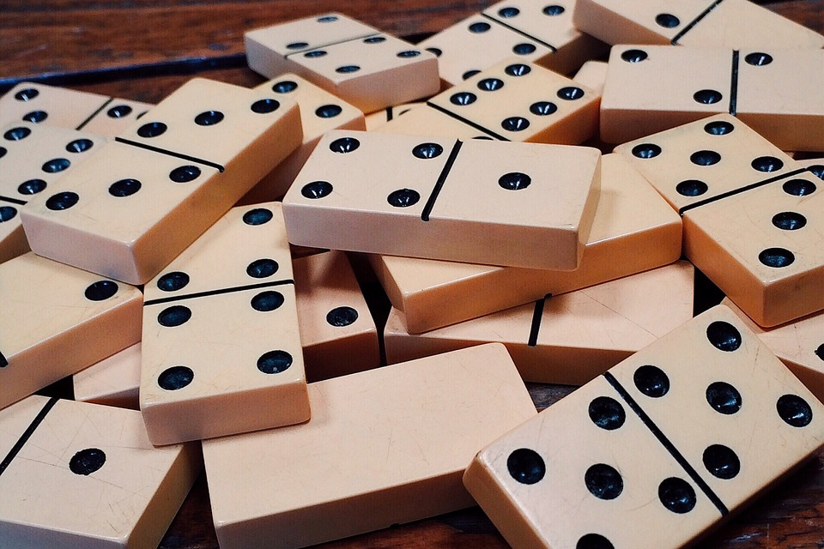
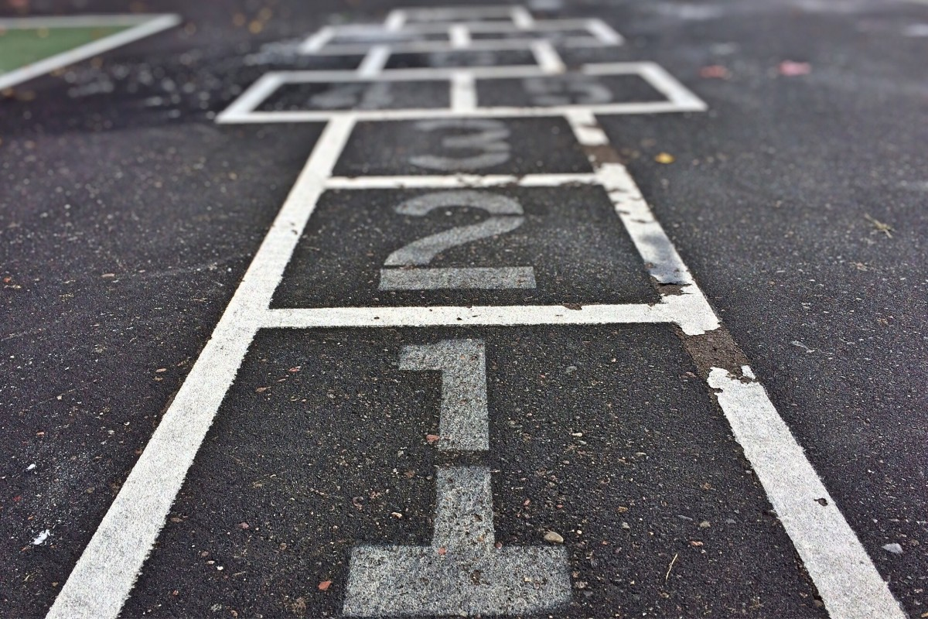
Step 4: Having learned the rules or the pattern in the chosen game or craft a last part in this task is for children to become bold by breaking the rules and patterns and trying to create something related but innovative and new!
Picture 7: Domino
- Can you break the rule to change the game?!
- Improvise a new game! Improvise a new craft.
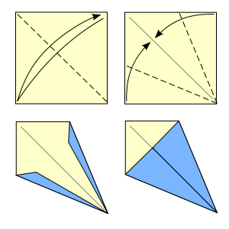
By a slight shift of the rules such as adding, subtracting or even diverting or distorting specific elements in the rule or the pattern something completely different may come up. Children can improvise with their unexpected constructions that may result into new games or crafts and will be the result of their in-between small group communication. In this space children can really have fun as they will be free to create their own games and crafts!
Picture 8: Street game
As an outcome of this task children can document the full process of becoming skilful at a game or craft and improvising their own new ones by making a poster or a video.
Task 3: Share your skilfulness
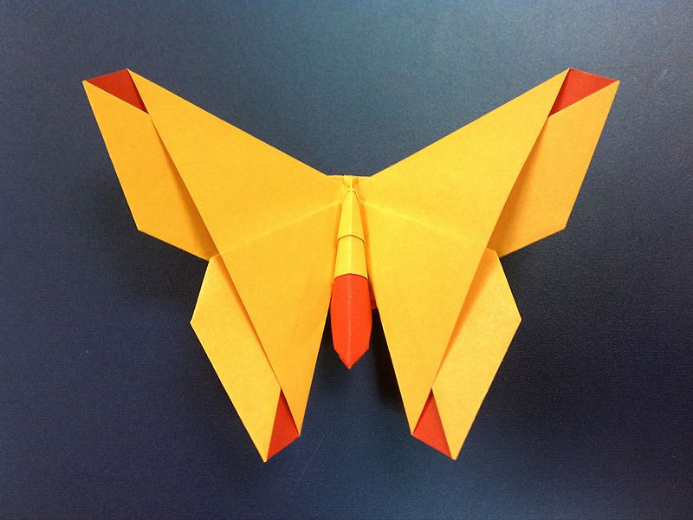
Being able to perform a refined technique in the context of game or craft is what characterises a skilful expert. In this activity the emphasis is on sharing our expertise with each other rather than using it to compete.
Picture 9: Origami steps
Step 1:
Invite your classmates for friendly games or craft-making workshops. Include experts and novices. Learn from each other.
- Share techniques and ideas in playing and making. Grow your competences, skills and ideas together.
- What new things have you learned? What stories about how things are being made amongst all of you?
Picture 10: Origami butterfly
Step 2: Invite people from the community who might have some expertise with the games or crafts you encounter and share experiences.
Share the techniques, strategies and ideas in playing and making.
- What new things do you learn?
- How do you expand your learning?
- How they might expand their own learning in being with you?
An outcome of this task can be the creation of an exhibition or forum presenting small groups experiences.
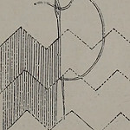
Task 4: Perform your expertise in the public sphere (optional)
This task focuses on bringing the mathematical games and crafts into the community itself. It involves the creation of hybrid spaces in the public sphere of the urban landscape where children can safely perform and share with others their expertise in playing games or making crafts. This will generate further opportunities for learning and becoming together with people who inhabit the specific place chosen and will contribute to growing confidence in children.
Picture 11: Knitting technique
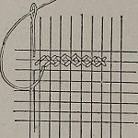
Teachers who want to take their children outside the school and into the community will need explore the specific permissions required from parents and principals. They also have to investigate if they are able to go on foot or if they need transportation organised through the school. The time and space out of school needs careful planning to ensure the children's safety: prior participant observation concerning the places to go with the children and negotiations with the people there are needed both for safety and informed consent.

Step 1: Discuss with children what might be suitable places in their nearby community where they would wish to go and perform their games and crafts. Explore what might be the pros and cons of performing at a particular place (for example, in terms of safety, opportunities for communicating and sharing experiences, accessibility). Focus on who might be the people they wish to meet with whom to share their expertise. Would they wish to ask them questions? Or explore more things with them?
Picture 12: Knitting technique
You can discuss with the children how space is shared out and to note, for example, that access to and use of space is often gendered.
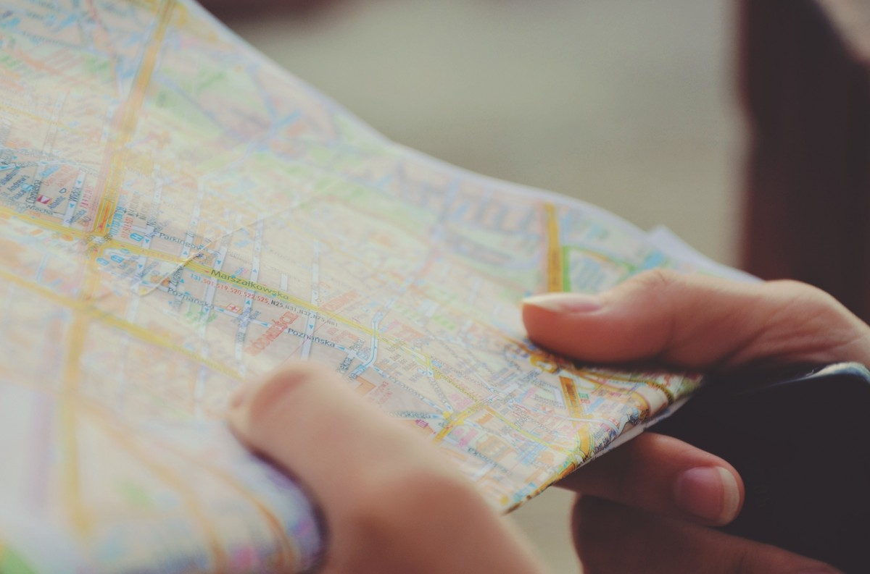
Based on a map (or a google map) you can create a plan for the places and people to visit. Children must think about the place and the people. Depending on time, try and limit children down to four visits at the most.
Picture 13: Landmark position
Having agreed the plan for the visit, children with their teachers will prepare for taking the walk in the places agreed. The children help draw up a detailed timetable for the day.
Step 2: The children take the walk around the community showing and sharing their expertise and learning from the members of the community that they meet. Encourage them to note down anything they observe and anything they learn.
Picture 14: Searching on the map
Step 3: Next day, upon return to school, discuss the experience as a whole and try to help the children identify what new things they have discovered and what the experience meant for them and their confidence in their mathematical abilities in the context of playing games and making crafts. Encourage students who feel they cannot perform as well as some of their peers to make sure their own skills, competences and ideas are being equally celebrated.
Extending the learning
Learning in this activity can be extended to both younger and older students. For younger students, games and crafts can be carefully chosen to fit kinaesthetic and cognitive competences. Specifically, versions of playing the domino or making simple origami crafts can be suitable for young ones. For them, particular steps for constructing algorithms could be facilitated by using already made cards with notation that can be used by children to unfold the procedure. Emphasis on slowing down the process of playing and making might create problems for some young children who might be impatient in their movements. In these cases, one may mediate to facilitate the process. Older children may be able to gain the most by appreciating the relative connections amongst cultural and cognitive processes all linked in the act of performing the game or the craft.
Other resources (material and human resources)
For all of the activities discussed above, a simple internet search will provide other linked mathematical activities. Further mathematical games and crafts can be also identified in digital forms such as video tutorials or instructions located in the internet.
Ethical issues or dilemmas
Playing and making are core practices in every community. They are culturally rooted and require the cooperative efforts of all our senses (hearing, seeing, moving and so on) and kinaesthetic abilities. Becoming an expert might not be always an easy task for all children. This activity aims to demystify how one may become skilled by unfolding the process through suggesting particular steps that aim to slow down the process, noticing rules and patterns, identifying techniques and refining them in the company of others. But, in every step, ethical dilemmas might occur as not all children have the same skills and competences and some might need more or less time than others. A basic issue here is how we allow ourselves and our children to become attentive to this complexity and how, in turn, we allow them time to refine their techniques at their own pace. In other words, how we encourage them to slow down and learn and share instead of becoming competitive amongst themselves.
In this, another important aspect might be the noticing of rules and patterns, techniques and procedures that could become combined or synthesized into the creation of an algorithm. That algorithm could, at its best, communicate the procedure to others who will be able to repeat it and play the game. Saying this, one may have in mind how difficult it may be to communicate in a symbolic language and this is the reason that the activity proposes the use of varied modalities such as oral or written language, descriptions in any form and use of the visual. Still, one must be alert to how the process of communication is not an easy one and demands much more attention. It is maybe here that the word sharing, instead of communicating, might capture in a more holistic way the deciphering of symbols along with the feeling of wishing to communicate with others. This is an important process in all mathematical activity.
Some for the activities, for example, dominoes or games which use dice, may be unacceptable for children of some faiths.
Source Information
Picture 1: Friendrich Sturm.The domino players.
Source: https://en.wikipedia.org/wiki/Dominoes

Picture 2: Smile 1931. Copyright free. Different Scripts of Numbers.
Downloadable from: https://www.stem.org.uk/

Picture 3: Smile 1931. Copyright free. The origins of the scripts.
Downloadable from: https://www.stem.org.uk/

Picture 4: pd4u [WTFPL or CC0] via Wikimedia Commons. Tangram basic-block.
Source: https://commons.wikimedia.org/wiki/File:Tangram_basic-block.svg

Picture 5: Unknown author [Public domain], via Wikimedia Commons. Tangram puzzle.
Source: https://commons.wikimedia.org/wiki/Tangram

Picture 6: Unknown author [CC0 Creative Commons]. Chinese Tangram Puzzle.
Source: https://pixabay.com/el/τάγκραμ-παζλ-κινέζικο-επτά-28892/

Picture 7: Unknown author [CC0 Creative Commons]. Game Domino- Dominoes Strategy. Source: https://www.maxpixel.net/Game-Domino-Dominoes-Strategy-1615704

Picture 8: Unknown author [CC0 Creative Commons]. Street Game.
Source: https://pxhere.com/en/photo/852241

Picture 9 Ftierce [Public domain] via Wikimedia Commons. Origami Steps.
Source: https://commons.wikimedia.org/wiki/File:Origami_kite_base.svg

Picture 10: Malachi Brown [CC BY-SA 2.0 (https://creativecommons.org/licenses/by-sa/2.0)], via Wikimedia Commons. The Alice Gray.
Source: https://commons.wikimedia.org/wiki/File:The_Alice_(origami_butterfly).jpg

Picture 11: Savage, E & Hale L. Image from page 26 of Art-needlework for decorative embroidery : a guide to embroidery in crewels, silks, appliqué (1879)
Source: https://www.flickr.com/photos/internetarchivebookimages/14584416538

Picture 12: Savage, E & Hale L. Image from page 25 of Art-needlework for decorative embroidery : a guide to embroidery in crewels, silks, appliqué (1879).
Source:https://www.flickr.com/photos/internetarchivebookimages/14584581667/in/photolist-odLWVy-odLX63-ouZeAR-ovePJU-ouZfa6-otewHA-odMN1B-ov4nhN-oteAcu-ov4pDb-ox2kBK-ox2kmz-odMJVP-odLSBd-ovgxtM-odLwMf-odLziN-ovgvYc-ovePUy-ovgxB2-ouZgax-odLBBA-odLwA3-otexeW

Picture 13: Fabián Alexis [CC BY-SA 3.0 (https://creativecommons.org/licenses/by-sa/3.0)], via Wikimedia Commons. Google maps.
Source:https://commons.wikimedia.org/wiki/File:Antu_google-maps.svg

Picture 14: Unknown author [CC0 Creative Commons]. Map
Source: https://pxhere.com/el/photo/934537

